Problem Statement 3: Customer and Sales Performance – Framing Note
Business Analyst, Global Retail Analytics | For: Chief Commercial Officer | Tool: Power BI
Evidence base: 589,959 identified buyers, 1 Jan 2023 – 18 Mar 2025, all amounts in USD (1 EUR = 1.08, 1 GBP = 1.27, 1 CNY = 0.14). Returns are netted out of sales. 2025 is only ever compared with the same dates in 2024. Figures are calculated from the dataset.
Situation. Zara has almost 600,000 identified customers, but the commercial team reports only total sales. Complication. Net sales grew just 1.3% in 2024 while active customers grew 19.3%, so revenue per customer fell from $190 to $161, and half of all customers (51%) have bought only once. Question. Who are our customers, do first-time customers come back, and how do we make more of them return?
Problem statement. The Chief Commercial Officer is facing many first-time customers who never buy again while trying to grow sales, which results in marketing spend that does not build a loyal base. How might we help first-time customers find a reason to come back, so that more of them buy again within 90 days? Job to be done (customer): when my first Zara purchase went well, I want a reason to return at the right moment, so I can keep my wardrobe fresh without searching around.

1. AARRR funnel
One actionable metric per stage that this dataset can measure, and the data Zara would need where it cannot.
Stage | Metric (measurable here) | Current value | Data Zara would need
Acquisition | New customers per period (first purchase) | 239,170 in 2024 (53,748–67,878 per quarter); peaks in Jan, Jul and Dec | Acquisition channel, cost per new customer, web/app visits, store footfall
Activation | Share of new customers who buy again within 90 days (the "aha" moment) | 28.7% overall; 30.7% if the first purchase was full price, 21.7% if marked down | App or loyalty sign-up, email consent, online vs in-store split
Retention | Quarterly cohort retention | 21–34% buy again the next quarter; 14–20% still buy four quarters later | Loyalty membership, churn reasons
Revenue | Revenue per active customer | $161 in 2024 ($190 in 2023); top 20% of customers = 60.8% of revenue | Customer-level margin after returns and promotion cost
Referral | Not measurable in this dataset | – | Referral codes, NPS/CSAT survey, social-share and review data

2. North Star metric
Repeat customers per quarter = customers who bought in the quarter and had bought from Zara before. Baseline (2024): Q1 63,207 | Q2 70,011 | Q3 73,279 | Q4 84,120. 2024 is the clean baseline, because early-2023 customers who shopped before the data begins look "new".
- Business goal → product goal. The business goal is profitable growth; the product goal is a behaviour: first-time customers come back. This metric counts exactly that behaviour.
- Not a vanity metric. Deeper discounts can inflate net sales and one-off buyers can inflate total customers; this metric only grows when people return.
- Tied to revenue. Returning customers generated 63.7% of net sales in 2024.
- Leading inputs: new customers per quarter, 90-day repeat rate, next-quarter retention, purchase frequency. Target: +8% repeat customers per quarter against the same quarter of 2024, to be confirmed by the A/B test.

3. Opportunity solution tree
Outcome: more first-time customers buy again (raise the 90-day repeat rate from 28.7% to 31%). Each opportunity comes from the data, not from a feature idea.
Opportunity (evidence) | Solution | Experiment
A. Sale-season first-timers repeat much less (21.7% vs 30.7% within 90 days; 22% of their later spend is on markdown vs 9%) | A1. Voucher valid only on full-price new arrivals, 14 days after the first purchase | A/B test (section 4)
 | A2. Personalised "new in" email based on the sub-category first bought | A/B test: email vs no email
B. Half of customers never come back (51% bought once; cohorts lose 66–79% in the next quarter) | B1. 30-day post-purchase email with complementary styles | Holdout: 10% of first-timers get nothing
 | B2. Free size exchange for first-timers (returns are highest in dresses and jeans, 17–18%) | Pilot in two stores vs matched stores
C. First purchases are price-led, not collection-led | C1. Early access to the new collection | A/B test: invite vs none

4. Experiment design: retention offer for first-time customers
Item | Design
Hypothesis | We believe that a voucher valid only on full-price new arrivals, sent 14 days after a first purchase that included a markdown, will raise the 90-day repeat rate for sale-season first-timers, because it gives them a reason to return at full price. We will know this is true when their repeat rate rises from 21.7% to at least 24.7%.
Target group | First-time customers whose first basket included a marked-down item, enrolled over 4 weeks of the January sale (January 2024 alone had 24,584 first-time customers).
Control group | Same eligibility, randomly split 50/50, receives no voucher or message.
Primary metric | Share who make a second purchase within 90 days of the first.
Guardrail metrics | Gross margin % on second purchases no more than 2 points below control; markdown share of second-purchase sales not above control; return rate not higher.
Sample size and duration | About 3,100 per group (95% confidence, 80% power, +3 points from 21.7%); plan for 5,000. About 17 weeks: 4 weeks enrolment plus 90 days follow-up.
Decision rule | Roll out if the primary metric rises significantly and no guardrail is breached.

5. Requirements: dashboard backlog
Epic ZARA-100: Weekly Customer and Sales Performance Dashboard (Power BI, five pages). Priority uses MoSCoW.
Story | As a … I want … so that … | Acceptance criteria (Given / When / Then) | MoSCoW
ZARA-101 | As the CCO, I want KPI cards with YoY change, so that I see weekly performance at a glance. | Given a year is selected, when the page loads, then cards show net sales, invoices, AOV and active customers with YoY; 2025 compares with 1 Jan–18 Mar 2024 only. | Must
ZARA-102 | As a regional leader, I want a store map, country comparison and league table, so that I can find strong and weak markets. | Given any country, when I right-click it, then drill-through opens its stores; tooltips show sales, invoices and AOV together. | Must
ZARA-103 | As the CCO, I want new vs returning customers by month, so that I see when customers arrive and come back. | Given 2024, when I view the chart, then new = 239,170 and returning = 121,596; Jan–Mar 2023 are blank (warm-up). | Must
ZARA-104 | As a CRM manager, I want a cohort retention matrix, so that I can see how many first-timers buy again. | Given cohorts from 2023 Q2, when I view the matrix, then each row shows retention by later quarter and the partial 2025 Q1 is labelled. | Must
ZARA-105 | As a marketing lead, I want RFM segments and the top-20% revenue share, so that I can target the right groups. | Given all buyers, when I view the page, then segments cover 100% of buyers and the top-20% share shows 60.8%. | Should
ZARA-106 | As an operations lead, I want a month × weekday heatmap, payment mix and tourist share, so that I can plan staffing and payments. | Given a country, when I view the page, then days run Mon–Sun, months Jan–Dec, and payment mix sums to 100%. | Should

Wireframe
Hand-drawn sketch of the five pages; the paper original is photographed and added to the repository.
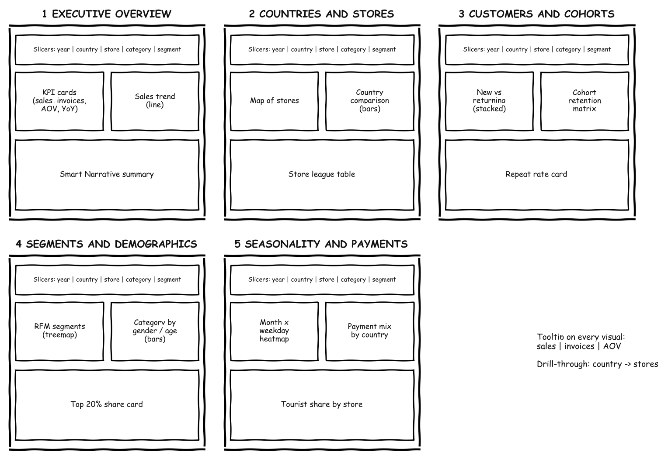

Assumptions and limits
- Customers whose first purchase falls in Jan–Mar 2023 may have shopped before the data began, so acquisition and repeat measures start on 1 Apr 2023.
- 90-day repeat rates use first purchases from 1 Apr 2023 to 18 Dec 2024, so everyone has 90 days of follow-up. The data is simulated for teaching.

